Sharing Your Ideas
A collection of some of the ideas and approaches
being used within our Partnerships

Foreword
Partnerships are still a relatively new feature of the landscape within our Diocese. In the words of Bishop Séamus, ‘They offer our Diocese unlimited potential as we seek to ensure viable and flourishing communities of people who want to deepen their commitment to Jesus and witness to him in our world.’ They also offer the opportunity for us to try out new approaches and think differently about how we do things.
Just one year on from establishing our 18 Partnerships it is encouraging to see that already many creative and practical ideas for building and developing them have emerged. This document provides an insight into some of the ideas that have come to our attention. We know that there will be many more that we haven’t yet heard about and would encourage everyone involved in Partnerships to share their ideas with the rest of our Diocesan family.
We have drawn heavily on the responses to the ‘Partnerships – One Year On’ reflection and are very grateful to everyone for their contributions to this. Indeed, we are hugely grateful for the time, energy and commitment that so many people are putting into ensuring that our Partnerships are built on firm foundations.
… ‘we seek to ensure viable and flourishing communities of people who want to deepen their commitment to Jesus…’
Bishop Séamus

Introduction
The majority of the ideas and approaches presented here are taken from the responses that Partnerships made to the ‘Partnerships – One Year On’ review process, particularly drawing from two areas of the document, namely:
- What Partnership developments or activities have been particularly fruitful, successful and energising?
- Please describe any specific activities or approaches that you feel would be of interest to other Partnerships.
Contributions have been grouped into themes and reference is made to the Partnership or Partnerships providing each example. When collating the responses we were conscious that this was very much a ‘snapshot in time’ of just some of the many activities taking place. It is in no way comprehensive or fully representative and some Partnerships have offered several examples while others have offered few. Nevertheless we hope you find the resource of value and something to be built upon as we work together to develop our Partnerships.

Worshipping Together
- Worshipping together at Partnership Masses was highlighted by Brinkburn, Seaton Delaval, Bede, John Ingram, Monkwearmouth and Benedict with the patronal feast of the church or Partnership often being the focus. Heavenfield’s Lenten Station Masses have helped Parishes to become more aware of each other and have strengthened friendships and contacts. The celebrations are often followed by a social event.
- Hogarth referred to bringing Parishes together for joint Triduum celebrations and a Women’s Day of Prayer.
- An Advent Service in Finchale included each Parish contributing leaves for a Jesse tree while in Bede, Advent Candles were distributed to every household in Partnership Parishes on the First Sunday of Advent along with a short invitation to encourage families to pray together for a few minutes each day in preparation for Christmas.
- The positive impacts of Area Missions were highlighted by the Partnerships where these have taken place. In Pontop the Mission gave the opportunity for parishioners without a connection to the primary schools to see ‘some of the wonderful things that are happening within our faith school communities’. In Benedict, a Mission that was already in the planning stage for some of the Parishes in the Partnership was widened with invitations to the other Parishes once the Partnership had been announced. This became an effective early step in establishing the Partnership and sharing activities. Escomb made reference to the intergenerational praise and song, anointing service and Family Night with the Youth Ministry Team which featured as part of their Mission.
Communications
- Several Partnerships have developed Partnership-wide newsletters or bulletins including Lindisfarne, Benedict and Finchale who also highlight making good use of Parish newsletters for Partnership items. Monkwearmouth produce a colourful quarterly Partnership Magazine and Escomb’s Partnership Note is produced weekly.
- Partnership logos have been designed in a number of Partnerships including Ovingham, Blackfriars, St Mary the Virgin and Pontop. They are seen as helping to create a sense of belonging across the Partnership.
- Ovingham, Escomb and John Ingram are among the Partnerships to have developed and distributed a Partnership Prayer for use across all Parishes in the area.
- Use of websites for Partnership information is mentioned by Jesmond St Mary, Heavenfield, Monwearmouth, Tynemouth Priory and Finchale.
- Finchale has produced A5 flyers with Partnership diary dates for Christmas and Easter celebrations and events over the summer.
Time to Reflect
- Several Partnership Development Groups highlighted the benefit of ‘away-days’, study days and retreats with the common theme being the importance of an extended time together to reflect, pray, plan and get to know one another.
- Lindisfarne decided to arrange their ‘away-day’ in a non-church venue and Benedict held a residential retreat at the Emmaus Youth Village where they explored the theme of Discipleship in a Missionary World. Their time together was a very effective team building exercise and helped with identifying key areas that fed into their Vision, Mission and Partnership Development Plan.
- John Ingram held their initial PDG gathering at Minsteracres with a focus on prayer and reflection and Blackfriars also used an ‘away day’ as a reflective way of getting the PDG started. Tynemouth Priory held a study day to plan the way ahead and Finchale organised a facilitated half-day at Ushaw College which gave everyone the chance to get to know one another on a more personal level and the opportunity to speak openly and objectively about concerns and anxieties.
Subgroups and Committees
- Over half of the Partnerships referred to the benefits of putting in place effective subgroups and committees with examples including Lindisfarne’s Spirituality, Finance, and Partnership Development Committees and Finchale’s six subgroups - Outreach, Young People, Prayer and Spirituality, Communications, Formation and Building Our Community. Heavenfield saw a key part of the role of the PDG as encouraging initiative from groups within the Partnership citing their delegated Communications Group and local Justice and Peace groups.
Social Activities
- Activities with a specific social focus were highlighted as ways of building relationships across the Partnerships. For example, Pontop has organised a Christmas social event at a neutral venue, a St Patrick’s Day Ceilidh, a Royal Wedding Party and a walking group. Monkwearmouth also held a Ceilidh to bring people together, while Escomb highlighted the benefit of social gatherings of the PDG for informal discussion prior to meetings as well as days out for Eucharistic Ministers.
- Other events which brought people together from across the Partnership included, for example, Flower Festivals in Lindisfarne, Pontop and Escomb and increased participation in the John Ingram Walk – an annual event commemorating the life and martyrdom of Blessed John Ingram, a Jesuit executed in Gateshead in 1594. Escomb held a ‘Songs of Praise’ event while in Hogarth they formed the ‘Partnership Players’ who performed a play ‘Great Expectations’, entertaining more than three hundred people at eight venues across their Partnership. During the interval, and after the show, actors were encouraged to mingle with the audience giving people from different Parishes the chance to meet.
Formation and Sacramental Preparation
- Blackfriars is piloting In Pursuit 20/20 a programme aimed at young people aged 25-45 exploring key aspects of discipleship delivered through monthly meetings and fellowship.
- Monkwearmouth has organised a Formation event to take place at each of their 11 churches over the next year. Tynemouth Priory ran the ‘Come to the Well and Drink’ course exploring and experiencing different ways of praying, while Lenten talks at one of the Parishes in Benedict were opened up to the whole of the Partnership increasing the attendance significantly and strengthening relationships
- Pontop has this year established a Confirmation Programme for the whole Partnership.
Prayer and Spirituality
- Heavenfield organised a Partnership Pilgrimage with participants walking from Saint Mary’s Hexham to Saint Oswald’s at Heavenfield. Finchale and Pontop highlight Partnership days of reflection while Monkwearmouth have planned a retreat for spring 2019.
- Prior to PDG meetings Pontop has introduced a time for extended quiet prayer wherever the meeting is to be held, encouraging parishioners from across the Partnership to come and pray together. The time of prayer continues during the meeting so that all decisions and deliberations are firmly rooted in prayer.
- Several Partnerships including Brinkburn, Seaton Delaval, Jesmond St Mary and Pontop have established spirituality networks and groups to take a lead in this aspect.
- Hilda comments that the main thrust of their Partnership is in engaging people and bringing them together and that their most fruitful developments have been centred on prayer and liturgies.
Finance and Administration
- In Lindisfarne, detailed procedures and associated documentation have been agreed for Partnership budget contributions and approval of expenses.
- Blackfriars is in the process of developing an administration handbook for the Partnership.
Open Meetings
- A small number of Partnerships referred to the benefits of holding open meetings, sometimes at ‘neutral’ venues to inform and engage a wider group. For example, Finchale has organised well-attended open meetings at Ushaw College, where people started to get to know each other, and at St Leonard’s School as part of the consultation on their Partnership Development Plan.
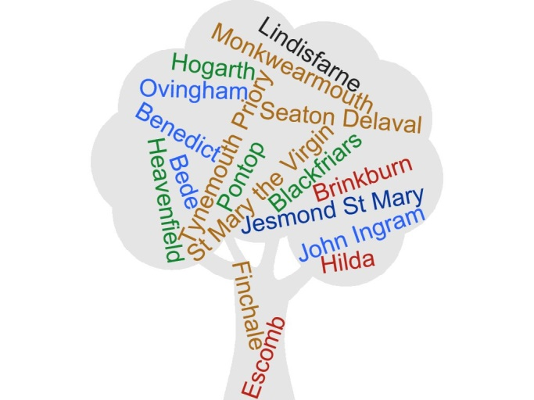
- John Ingram held five half-day workshops, one for each key element of their Partnership Development Plan. These were open to any parishioner from the Partnership and have not only informed the development of the plan but have also helped to build new relationships.
Moving Around the Partnership
- Several Partnerships have stressed the importance of everyone getting to know the different Parishes and churches within the Partnership area. Jesmond St Mary has made a point of visiting and learning about new Parishes and discovering how different they are. Brinkburn and John Ingram rotate meetings around the Parishes so as to include everyone. Bede has coordinated Sunday afternoon services during Advent and Lent in a different Parish each week, encouraging people to move around the Partnership.
Diocese of Hexham and Newcastle, Department for Development and Renewal
Tel: (0191) 243 3304 / E-mail: hope@diocesehn.org.uk / Web: www.rcdhn.org.uk

©Diocese of Hexham and Newcastle – September 2018
Also available in other formats

Young People
- A children’s workshop in Lindisfarne created a Partnership banner which is now circulating around their churches.
- St Mary the Virgin has involved schools in developing their Partnership logo and prayer and also highlighted the work of their Partnership Youth Council.
- Pontop has set up a Youth Development Group which sees schools, Parishes and families working in partnership. They took a representative group of children from primary and secondary schools to The Event in Hebburn and have hosted their first Partnership youth event, intending to run a similar activity once a term in different areas.
- Finchale comments that the use of school venues for events is a good opportunity to recognise the importance of the schools in the life of the Partnership. Benedict invited two school Chaplains to become members of the PDG helping to ensure that the schools and their students are kept in mind in PDG discussions and plans.
A leaflet outlining key contacts for Partnerships can be found at the bottom of the Partnership home page of the Diocesan website at www.rcdhn.org.uk

